Abstract

This report documents an internship-style engagement on the EROAS underwater vehicle navigation stack (github.com/AIRLabIISc/EROAS), carried out between May 11 and July 7, 2026. The objective of the engagement was to migrate the existing ROS 1 / Gazebo Classic implementation of EROAS to ROS 2 Jazzy with Gazebo Harmonic, and to bring the migrated simulation to a fully working, demonstrable state.
The work moved through three phases. The first involved understanding the existing system closely enough to plan a migration — its global-to-local path-planning pipeline, its CUDA-based preprocessing, and the research behind it — supported by a study of the DAVE underwater simulator and background reading on path-planning algorithms (RRT, RRT*), LAUV navigation, slender-body underwater navigation, and traversability mapping. The second phase covered execution of the migration itself, including recovery from a failed attempt to automate the conversion with locally hosted LLM agents, which corrupted parts of the codebase and forced a full manual restart. The third and longest phase focused on debugging the ported simulation: resolving Gazebo Harmonic plugin-loading failures, reimplementing sonar-ray visualization against Harmonic’s marker-based rendering architecture, fixing a broken pivot maneuver, correcting elongated-obstacle detection, damping vehicle oscillation, and completing an incomplete Control Barrier Function (CBF) integration.
By the end of the reporting period, the EROAS stack ran end-to-end under ROS 2 Jazzy and Gazebo Harmonic, with working sonar rendering and contour-based navigation in World A, and a fully ported SPD2C + CBF control stack with waypoint hovering.

Problem Statement

The EROAS navigation stack was originally built against ROS 1 and Gazebo Classic, both of which are now end-of-life. Continuing to develop and demonstrate the system required moving it onto a currently supported platform — ROS 2 Jazzy and Gazebo Harmonic — without losing any of its existing navigation, sonar-sensing, or control functionality.
This migration was non-trivial for several reasons. Gazebo Harmonic changes the plugin architecture and namespacing entirely; its rendering pipeline (gz-rendering / gz-gui) replaces Gazebo Classic’s direct OGRE calls with a marker-message-based system; and several of EROAS’s control and perception components — including its Control Barrier Function (CBF) constraints and its forward-looking-sonar-based obstacle detection — depended on implementation details that do not carry over automatically. Left unaddressed, these gaps would leave the ported system compiling but not actually functioning: silently missing visualizations, unstable vehicle motion, or missed obstacle detections.
An attempt to accelerate the file-by-file conversion using locally hosted LLM agents (Ollama running Qwen 3.5) surfaced a further problem: uncoordinated automated edits corrupted shared files across the codebase, making clear that the conversion needed careful, verifiable, largely manual execution rather than a purely automated one.

Introduction

EROAS is an underwater autonomous-vehicle navigation stack combining global and local path planning, forward-looking-sonar-based perception, and Control-Barrier-Function-based safe control. Built and simulated on ROS 1 with Gazebo Classic, the project needed to move onto ROS 2 Jazzy with Gazebo Harmonic to remain usable and extensible going forward.
This report covers the work carried out on that migration between May 11 and July 7, 2026: first running and understanding the existing system under WSL and VMware, then planning and executing its conversion to ROS 2, and finally debugging the ported simulation until it ran reliably end to end.
The sections that follow cover the problem in more detail, the objectives set for the engagement, the methodology followed, a full week-by-week account of the work, the issues encountered and how each was resolved, and the outcome as of the end of the reporting period.

Objectives

- Understand the existing system. Run the EROAS repository under WSL and VMware and trace its global-path-planning-to-local-path-planning pipeline, to build a complete picture of the system before modifying it.
- Migrate the stack to ROS 2 Jazzy / Gazebo Harmonic. Convert every package in the repository — control, thruster allocation, trajectory, sonar simulation, rendering — from ROS 1 / Gazebo Classic APIs to their ROS 2 Jazzy / Gazebo Harmonic equivalents, without losing functionality.
- Restore full simulation fidelity. Get the ported simulation not just to compile, but to actually run and render correctly — working sonar visualization, correct obstacle detection, and stable vehicle motion.
- Complete and validate the safety-control layer. Port and finish the SPD2C + Control Barrier Function (CBF) control stack, including waypoint-hover mode, and validate it across multiple test worlds.
- Ground the local-planning approach in the literature. Study traversability mapping, RRT / RRT*, and LAUV obstacle-avoidance research as background for the system’s local planning layer.

Methodology

- Environment setup and baseline understanding. Ran the existing ROS 1 system under WSL and on a VMware virtual machine to observe its behavior first-hand before making any changes.
- Conversion planning. Broke the migration down sub-directory by sub-directory and sequenced the order of conversion before starting.
- Automated-conversion experiment and recovery. Tried accelerating the conversion with locally hosted LLM agents (Ollama + Qwen 3.5); when this corrupted the codebase, audited every file by hand and restarted manually.
- Manual, file-by-file ROS 2 porting. Converted each package by hand — headers, sources, launch files, world files — validating each one before moving to the next.
- Reference-driven debugging. Whenever a fix wasn’t obvious from the ROS 2 / Gazebo Harmonic documentation alone, went back to the relevant upstream repository (gz-sim, ros_gz, the DAVE simulator, the original nps_uw_multibeam_sonar package) or to the research literature behind the affected component.
- Iterative multi-world testing. Validated fixes across several purpose-built test worlds rather than a single scene, to confirm each fix generalized instead of just working in the case it was first noticed in.

Running the Simulation

The commands below run the current state of the repository end to end — from a fresh WSL shell, through building and launching World A, to viewing the live sonar rays. They assume ROS 2 Jazzy and the eroas_ws workspace are already installed inside the Ubuntu-24.04 WSL distro.

Open the environment
wsl -d Ubuntu-24.04
source /opt/ros/jazzy/setup.bash
source ~/eroas_ws/install/local_setup.bash
  - wsl -d Ubuntu-24.04 — opens a WSL shell in the Ubuntu-24.04 distro specifically, not whichever distro is set as WSL’s default — ROS 2 Jazzy and the workspace are only installed there.
  - source /opt/ros/jazzy/setup.bash — loads the base ROS 2 Jazzy environment (the
ros2 CLI, message and service definitions) into the current shell.
  - source ~/eroas_ws/install/local_setup.bash — layers the EROAS workspace’s own built packages (navigator_auv, nps_uw_multibeam_sonar, rexrov2, etc.) on top of the base ROS 2 environment, so ros2 launch / ros2 run can find them.

Pull the latest code
# In WSL "Ubuntu-24.04" — NOT the default "Ubuntu" distro
cd ~/eroas_ws/src/uuv_simulator # or wherever your clone of EROAS lives
git pull origin fix/eroas-world-a-navigation
  - Moves into wherever the EROAS clone lives inside the workspace, and pulls the fix/eroas-world-a-navigation branch — the branch carrying the Week 9 / Aug 17 sonar-visualization and stuck-recovery fixes described above.

Build the workspace
cd ~/eroas_ws
source /opt/ros/jazzy/setup.bash
colcon build --packages-select uuv_assistants # 4.
# Source the workspace fresh (bug 2 sometimes clears with a clean re-source; # if it recurs, that's the still-open investigation)
source install/local_setup.bash # 5.
  - colcon build --packages-select uuv_assistants — ROS 2’s build tool, scoped here to a single package for a faster rebuild after a small change. Drop --packages-select uuv_assistants for a full colcon build if more than that one package changed.
  - source install/local_setup.bash — re-sources the freshly built packages into the current shell so the changes actually take effect. Noted in the project’s own notes as a workaround for a specific open bug (“bug 2”): a clean re-source sometimes clears it, and if it doesn’t, that’s still an open investigation rather than a solved one.

Launch the simulation
ros2 node list
thruster_ros_plugin_0..5
ros2 topic hz /rexrov2/blueview_p900_point_cloud
# should list ~10-19 nodes incl.
# should hold steady, not stall
ros2 launch rexrov2_gazebo start_EROAS_demo.launch.py world_name:=world_a
# (headless / matches the project's own diagnostic-run command)
ros2 launch rexrov2_gazebo start_EROAS_demo.launch.py gui:=false world_name:=world_a start_navigator:=true start_cbf:=true
  - The first form launches Gazebo Harmonic with its GUI and loads world_a — the paper’s Figure-8 navigation scenario.
  - The second form adds gui:=false (no rendering window, useful over SSH or for long unattended runs) and explicitly starts the navigator and CBF nodes with start_navigator:=true start_cbf:=true — this is the exact command used for the project’s own headless diagnostic-run log captures (referenced throughout Week 9).

Verify it’s healthy

  - ros2 node list — lists every running ROS 2 node; a healthy launch shows roughly 10–19 nodes, including six separate thruster_ros_plugin_0–5 instances, one per thruster.
  - ros2 topic hz /rexrov2/blueview_p900_point_cloud — reports the publish rate of the sonar’s point-cloud topic; it should hold a steady rate rather than stall, confirming
the sonar sensor is actually producing data continuously rather than just having started.

View the sonar rays live
rviz2 -d ~/eroas_ws/src/navigator_auv/rviz/sonar_rays.rviz

Run in a second shell (repeat step 1’s wsl -d Ubuntu-24.04 and ROS 2 sourcing first). This opens RViz2 pre-loaded with the sonar_rays.rviz config added in Week 9’s Aug 17 work, which subscribes to /rexrov2/sonar_ray_markers and renders the live blue sonar cone — this is the custom bridge that replaced Gazebo Harmonic’s native ray visualization, which (as
covered in Week 9) has no way to default to “on” from the world file the way Gazebo Classic did. Gazebo Harmonic’s own Visualize Lidar panel (Display Lidar Visual / Show Non Hitting Rays) can still be opened directly in the Gazebo GUI as a native alternative, but it has to be pointed at
the sonar’s topic manually each session rather than coming on by default..
The table below gives a quick-reference view of the reporting period; the detailed week-by-week account follows.

Week | Dates | Focus area
Week 1 | May 11 – 17 | Environment setup, repo bring-up, background research, conversion planning
Week 2 | May 18 – 24 | LLM-assisted conversion attempt, codebase corruption, manual recovery begins
Week 3 | May 25 – 31 | Manual, file-by-file ROS 2 migration continues
Week 4 | Jun 1 – 7 | ROS 2 Jazzy / Gazebo Harmonic migration completed; simulation task assigned
Week 5 | Jun 8 – 14 | Simulation bring-up; Gazebo plugin issues; test-world creation
Week 6 | Jun 15 – 21 | Sonar visualization debugging; plugin substitution
Week 7 | Jun 22 – 28 | Pivot mechanism, rendering, and oscillation debugging
Week 8 | Jun 29 – Jul 5 | World A sonar/contour navigation fix; full SPD2C+CBF stack ported
Week 9 | Jul 6 – 7 | Validation and wrap-up, then most-recent sonar visualization / stuck-recovery / dead-end fixes

Week 1 (May 11 – May 17): Environment setup, background research & conversion planning
The week started with just getting things running. Once WSL was set up, I spent a good amount of time simply exploring the codebase — running the system, watching how it behaved, and tracing the flow from global path planning down to local path planning so I actually understood the architecture before touching anything. I also ran the same setup on a VMware VM as a second environment to cross-check behavior. Along the way I mapped out exactly what was going to break the ROS 2 / Gazebo Harmonic migration — deprecated APIs, plugins with no direct equivalent, build-system differences — and got the world files loading and running properly.
- Installed and configured WSL to run the EROAS repository locally, and ran the system on a VMware virtual machine as well, to see whether behavior held up outside WSL.
- Investigated the CUDA dependency in the pipeline and dug into why it is specifically needed at the preprocessing stage.
- Read through the research paper behind the existing system to understand the reasoning behind its design.

- Went through the DAVE underwater vehicle simulator as a reference for how a working ROS 2 / Gazebo-based underwater sim is put together.
- Put together a plan of action for the conversion — going sub-directory by sub-directory
— and started the conversion itself.
The second half of the week turned into more of a reading week. I started looking into traversability maps out of curiosity about whether they could be integrated into the navigation stack later, which led me down a path-planning literature rabbit hole — RRT* versus plain RRT, LAUV obstacle-avoidance strategies, and a few papers on neural-network-assisted sampling for planners. None of it was implemented yet, but it shaped how I thought about the local planner for the rest of the internship.
- Researched traversability maps: the concept, how one might integrate into this navigation stack, and its processing pipeline, backed by a handful of research papers.
- Compared RRT* against different path-planning algorithms and LAUV obstacle-avoidance approaches.
- Read up on the LAUV (Light Autonomous Underwater Vehicle) platform and came across slender-body navigation as a related concept for underwater vehicles, which I explored further.
- Looked closely at the difference between RRT and RRT*, the challenges and open problems each has, and how neural-network-based implementations try to address them.

Week 2 (May 18 – May 24): LLM-assisted conversion attempt & manual recovery
Manually converting file after file was slow, so I installed Ollama locally with the Qwen 3.5 model and set up multiple agents to run the ROS 1 → ROS 2 conversion in parallel across the codebase. In theory this should have saved days. In practice, the agents ended up editing overlapping files without any real coordination and cross-contaminated the codebase — imports from one package bled into another, half-converted files got mixed with untouched ones, and it became hard to tell what state anything was actually in.
I lost a day just to realizing how bad it was. Once it was clear the agent-driven approach wasn’t salvageable, I went through every repository, folder, and file by hand to figure out exactly what had been touched and how badly, and then started the conversion over from scratch — manually, file by file, including headers, source files, and everything else listed in each package. It was slower than doing it right the first time would have been, but it meant I actually understood every change going forward.
- Installed Ollama locally with the Qwen 3.5 model to try to speed up the ROS 1 → ROS 2 conversion, and ran multiple LLM agents in parallel to automate conversion of repository files.

- The agents cross-edited and mixed up files across the codebase, corrupting the in-progress migration.
- Manually audited every repository, folder, and file to assess the extent of the damage.
- Restarted the conversion from scratch on a fully manual, file-by-file basis — headers,
.cc/.cpp sources, and every file listed per package — abandoning the agent-driven approach.

Week 3 (May 25 – May 31): Manual, file-by-file ROS 2 migration
With the automated approach out of the picture, this week was steady, unglamorous progress: one module at a time, checked and re-checked. I converted the EROAS trajectory and interpolator modules, went back over previously converted code to make sure it actually held up, and tackled the OGRE-based selection system, which had to be rewritten against Gazebo
Harmonic’s gz-rendering8 API since the old OGRE calls simply don’t exist anymore in Harmonic’s rendering stack.
- Added and converted the EROAS trajectory and interpolator modules to ROS 2.
- Continued updating and validating converted EROAS code module by module.
- Converted the OGRE-based selection system to Gazebo Harmonic’s gz-rendering8 API for ROS 2 compatibility.

Week 4 (Jun 1 – Jun 7): ROS 2 Jazzy / Gazebo Harmonic migration completed
Everything from the previous two weeks converged this week. I finished converting the navigator_auv nodes, ported the entire nps_uw_multibeam_sonar package — source, models, URDF, tools, worlds, docs, analysis scripts, all of it — and did a proper cleanup pass on the repo, stripping out stale build/install/log directories and leftover files from the failed agent-driven attempt. By the end of the week the ROS 2 Jazzy + Gazebo Harmonic migration for the DAVE/UUV stack was actually running. It felt like the hard part was over. New task from here: show the simulation actually working end to end, which meant going back through files I thought were “done” to wire them together properly.
- Completed conversion of navigator_auv nodes from ROS 1 to ROS 2 Jazzy.
- Ported the nps_uw_multibeam_sonar package in full: source files, models, URDF, tools, worlds, documentation, and analysis scripts.
- Cleaned up the repository by removing build/install/log directories and leftover migration/temporary files, and integrated the RexROV simulation and world launch configuration.

- Reached a state where the ROS 2 Jazzy + Gazebo Harmonic migration for the DAVE/UUV stack ran successfully, and was assigned the task of demonstrating the working simulation.

Week 5 (Jun 8 – Jun 14): Simulation bring-up & Gazebo plugin issues
The first thing that went wrong was the world simply refusing to load — plugin-not-found errors, or plugins loading but silently doing nothing. ROS 1 plugins are declared and namespaced completely differently from how Gazebo Harmonic’s gz-sim expects them (the old
gazebo_ros-style plugin tags don’t map onto the new gz::sim::systems namespace, and a lot of the SDF itself was still written against the older SDF 1.6 spec instead of the 1.9/1.10 that Harmonic parses). Rather than guess my way through it, I went back to the source: I read through the gz-sim and ros_gz repositories directly to understand how the new plugin system is actually structured, and cross-checked against the DAVE simulator repo, since it already had a working Harmonic-era plugin setup for underwater thrusters and sensors I could use as a known-good reference. I also went through open issues on the gz-sim and gazebo_ros_pkgs GitHub trackers, since it turned out I wasn’t the only person who’d hit “plugin not found” errors migrating from Classic to Harmonic — a few of those threads pointed straight at the namespace change I’d missed.
Once plugin loading was more or less sorted, I built out several new test worlds — a simple corridor, an open tank, and a cluttered obstacle field — specifically so I could isolate whether a given failure was a world-file syntax problem, a missing plugin binary, or an actual bug in the ported planning/avoidance code. Having more than one world to test against turned out to matter a lot later, once the sonar and control bugs showed up, because it let me confirm a fix generalized instead of just working in one specific scene.
- Worked through Gazebo Harmonic plugin-loading failures blocking simulation start-up, tracing them to the ROS 1 → Harmonic plugin-namespace and SDF-version mismatch.
- Read through the gz-sim and ros_gz repositories to understand Harmonic’s plugin architecture, and used the DAVE simulator’s plugin configuration as a working reference.
- Went through GitHub issue threads on gz-sim and gazebo_ros_pkgs for similar Classic-to-Harmonic plugin migration problems.
- Built multiple additional test worlds — corridor, open tank, cluttered field — to validate whether the ported planning and avoidance algorithms behaved correctly under different conditions, and to have a consistent baseline for testing later fixes.

Week 6 (Jun 15 – Jun 21): Sonar visualization debugging

This one was confusing at first because nothing looked broken from the data side: echoing the sonar topic showed correct range readings, so the sensor was clearly computing the right thing. The rays just weren’t drawn on screen. My first instinct was that it was a plugin problem like Week 5, so I tried swapping in a few different Gazebo Harmonic rendering plugins to see if one of them would pick up the visualization — none of them did, which told me the actual problem was architectural, not a missing plugin.
To understand what was actually supposed to be happening, I went back to the original nps_uw_multibeam_sonar repository — the upstream ROS 1 / Gazebo Classic implementation
— to see exactly how it drew the sonar rays. It turned out Classic did this by calling directly into OGRE’s SceneManager and RTShader system, which no longer exists in Harmonic’s rendering
stack at all. Harmonic’s gz-rendering/gz-gui pipeline works completely differently: visuals are published as gz::msgs::Marker messages on a topic and picked up by the scene renderer,
rather than drawn directly by the sensor plugin. I hadn’t reimplemented that marker-publishing step at all — that was the actual bug, not anything plugin-related. I looked at how gz-sim’s own LiDAR visualization plugin publishes its ray markers as a working pattern, and adapted the same approach for the sonar cone. Once markers were publishing, a second issue showed up — the rays would just accumulate on screen frame after frame instead of clearing, so I had to add
proper marker lifecycle/cleanup logic (deleting the previous frame’s markers before publishing the next set) to get a clean, live sonar sweep instead of a smear.
- Confirmed the sonar sensor itself was computing correct range data — the bug was purely in visualization, not sensing.
- Tried importing and swapping several different Gazebo Harmonic rendering plugins first, which ruled out a simple plugin-compatibility fix.
- Went back to the upstream nps_uw_multibeam_sonar (ROS 1 / Gazebo Classic)
repository to see how it originally drew sonar rays via OGRE’s SceneManager/RTShader
— an approach with no equivalent in Harmonic.
- Studied Gazebo Harmonic’s gz-rendering / gz-gui marker-based visualization architecture, and used gz-sim’s built-in LiDAR ray-visualization plugin as a reference pattern for how markers should be published.
- Reimplemented sonar ray visualization using gz::msgs::Marker publishing instead of the old direct-OGRE approach, and fixed a follow-on bug where markers accumulated instead of clearing, by adding per-frame marker cleanup before each new sweep was published.

Week 7 (Jun 22 – Jun 28): Pivot mechanism, rendering & oscillation issues
Pivot mechanism. In-place turning worked fine in Gazebo Classic through a specific joint-controller setup, but under Harmonic the same maneuver made the vehicle lurch instead of

rotating cleanly. I pulled up the original ROS 1 thruster allocator source next to the ROS 2 port and went through the thrust-mixing matrix logic line by line until I found where torque distribution across the thrusters had quietly diverged during the earlier conversion — a sign that Week 2’s file mix-up had left a subtler mark than I’d realized. I also checked a couple of open-source AUV thruster-manager implementations on GitHub to compare how they handled yaw/pivot gain tuning, which helped me sanity-check the fix instead of just tuning by feel.
Elongated-obstacle detection. Long, thin obstacles — pipes, rails, anything angled — weren’t being picked up reliably by the forward-looking sonar, even though smaller compact obstacles detected fine. This traced back to rendering again: the ray-casting resolution and culling behavior in gz-sim wasn’t accounting properly for how an elongated object looks at oblique angles, effectively letting thin objects fall between rays. I went into the gz-sensors source for the sonar sensor plugin to check the ray-count and field-of-view parameters it was using, and cross-referenced a research paper on forward-looking sonar coverage for slender obstacles that I’d bookmarked back in Week 1 while reading about slender-body navigation — it turned out to be directly relevant here, not just background reading.
Oscillation. Vehicle motion was oscillating at close to its maximum amplitude, which made anything downstream of it (path following, obstacle avoidance) unreliable. I went back through papers on damping and PID/PD tuning for underwater vehicles — the same ones the original EROAS design referenced for its control barrier function approach — retuned the gains, and added rate limiting on the control output. I re-ran this against all of the test worlds I’d built in Week 5, not just the one I’d first noticed the oscillation in, to make sure the fix actually generalized instead of masking the symptom in one scene.
- Compared the original ROS 1 thruster allocator against the ROS 2 port line by line to find where the thrust-mixing matrix had diverged, fixing the vehicle’s pivot / in-place-turn behavior.
- Checked open-source AUV thruster-manager implementations for yaw/pivot gain-tuning conventions as a sanity check on the fix.
- Traced elongated-obstacle detection failures to ray-casting resolution and culling in the FLS sonar sensor, by reading the gz-sensors sonar plugin source for its ray-count / FOV parameters.
- Revisited a research paper on forward-looking sonar coverage of slender obstacles (first read during Week 1’s slender-body-navigation research) to inform the fix.
- Diagnosed near-maximum-amplitude oscillation in vehicle motion; re-read underwater-vehicle PID/PD damping papers and the CBF references behind the original design.
- Retuned control gains and added output rate limiting, then validated the fix across all test worlds built in Week 5 to confirm it generalized rather than fixing one scene only.

Week 8 (Jun 29 – Jul 5): World A fix & full SPD2C+CBF stack port
With the sonar-rendering and control fixes from Weeks 6–7 in place, I brought them together in World A and fixed the remaining sonar and contour-navigation issues specific to that world. I then ported EROAS1’s full SPD2C+CBF control stack, added waypoint-hover mode, fixed spawn-position bugs, and raised simulation fidelity to 500. Testing this properly is what surfaced the last real gap: the CBF constraints themselves — and a few other pieces of the earlier conversion
- weren’t actually complete, just present. That meant going back through modules I’d already marked “converted” and finishing them properly, including the path-planning/obstacle-avoidance logic that had been left partially done since the original conversion pass.
  - Fixed sonar rendering and contour-based navigation for ROS 2 EROAS World A (Jul 1).
  - Ported EROAS1 to the ROS 2 stack in full: SPD2C + CBF control stack, waypoint_hover mode, spawn-position fixes, simulation fidelity raised to 500, hover_mode enabled (Jul 3).
  - Identified that the CBF (Control Barrier Function) constraints and portions of the earlier conversion were still incomplete, requiring another pass through the previously converted modules.
  - Revisited the path-planning / obstacle-avoidance conversion, which had not been fully completed in the initial pass.

Week 9 (Jul 6 – Jul 7): Validation, wrap-up & the most recent fixes
A short close-out to the original reporting period, then picked back up as the most recent block of work on the project: five commits going deep on World A’s sonar visualization and its stuck-recovery / dead-end logic.
With the World A navigation stack and CBF integration in a working state, I spent Jul 6–7 re-running validation and writing up exactly what was still fragile, so the next phase of work wouldn’t have to rediscover it from scratch. That next phase picked back up on Aug 17, directly off the back of the Jul 8 diagnostic that found velocity_cbf.py wasn’t actually consuming the sonar-derived obstacle data only_gap.py was publishing. This is the most heavily verified work in the whole engagement: every fix below was confirmed against an actual headless run log, not just code review.
  - Continued validation of the World A navigation stack and CBF integration, and consolidated findings on outstanding issues to carry forward.
Sonar ray visualization. Bridged the sonar’s ray-visual sensor to ROS 2 and added sonar_ray_markers.py plus an RViz2 config, because Gazebo Harmonic’s VisualizeLidar plugin has no way to default to “on” from the world file — Gazebo Classic auto-rendered this, Harmonic doesn’t. Alongside this, did a large cleanup pass on navigator_auv/scripts/, removing roughly 25 stale or duplicate files left over from earlier CBF and sonar-reconstruction experiments

(old_CBF variants, sonar_reconstruction_old, hover_patrol, and similar) that had accumulated across the migration.
Stuck-recovery for a fully-boxed pinch. Added recovery logic for the case where free_beams reads 0 on every bearing — the point where the CBF’s min-norm QP has no unconstrained direction left to project onto. The vehicle now backs away, sweeps the sonar across a wide yaw range to find the widest actual corridor, and turns onto it before resuming, rejecting candidates too close to the original heading since those only read “free” from increased standoff on the same wall, not a real opening.
Vertical-escape depth bound. The first attempt at fixing vertical escape (gating its depth-reached check on a minimum duration/distance) exposed a worse bug: that check compared against the original waypoint depth, and a real climb moves away from that monotonically, so it almost never re-satisfied — nothing was left bounding the climb except a 180-second timer. A
headless log caught one escape climbing continuously from −50 to −14.7, nearly surfacing. Fixed by ending the escape as soon as the gap-detection logic reports a real corridor again, instead of waiting on a depth or duration condition — the correct success signal and an inherent safety bound at once. Escapes now end in 4–6.5 seconds, with depth staying within about 0.1 m of the original target.
Closing-corridor detection. Traced a run where free_beams shrank cleanly — 103 → 88 → 57
→ 9 → 0 over about 15 seconds — until the vehicle was fully boxed in again: a wide-mouthed pocket that funnels to a dead end reads identically to a real through-corridor from the outside, so the existing no-progress timeout only caught it after driving fully in. Fixed by tracking the widest free-beam run seen recently during normal navigation; if it collapses to a small fraction of that peak, the system now treats it as a closing trap and backs away immediately. Traps are now caught in about 6 seconds instead of only after fully boxing in.
Dead-end heading memory. The vehicle kept re-triggering recovery in the same local area — nine attempts in one run, zero net progress — because “widest free run” is a poor proxy for “real through-passage”: a large dead-end bay reads as more open volume than a narrow but genuine corridor, so it always out-scores the real path on raw width, and picking the single global max is deterministic. Added known_bad_headings: once a heading is confirmed a dead
end, it’s excluded from candidacy, forcing later attempts onto a different, unproven heading.
Gap_follow dead-end exclusion. The heading memory above wasn’t enough on its own, because it only filtered stuck-recovery’s frontier scan, not gap_follow’s own candidate selection
- the instant the vehicle backed off a dead end even slightly, the next gap_follow cycle re-spotted that same direction looking marginally open again and cut straight back in. Applied the same known_bad_headings exclusion to gap_follow’s candidate filtering; a 15-minute isolated verification run confirmed this broke the vehicle out of a local cycling pattern that had trapped every previous run, in both directions of travel.
  - Added sonar_ray_markers.py and an RViz2 config to bridge Gazebo Harmonic’s sonar ray visualization to ROS 2, since VisualizeLidar has no world-file default-on option under Harmonic.

  - Added stuck-recovery for a fully-boxed pinch (free_beams=0 on every bearing), sweeping the sonar for the widest real corridor before turning onto it.
  - Fixed vertical-escape depth control, first gating its exit condition correctly, then bounding it against a surfacing runaway — escapes now end in 4–6.5s within ~0.1 m of the target depth, confirmed against headless log captures.
  - Added closing-corridor detection so funnel-shaped dead ends are caught in ~6s instead of only after fully boxing in.
  - Added known_bad_headings dead-end memory, and extended it to gap_follow’s own candidate filtering — verified via a 15-minute isolated run to break a local cycling pattern that trapped every prior attempt.
  - Removed roughly 25 stale or duplicate script files left over from earlier CBF and sonar-reconstruction experiments, as part of the same cleanup.
As of this commit, World A does not yet complete reliably end-to-end: a winding multi-pocket area (around y≈60–68) still traps the vehicle in some runs, and known_bad_headings has no expiry or positional scoping yet, so a heading can stay blacklisted even once the vehicle is far enough away that it no longer applies. Both are documented as open issues in navigator_auv/STUCK_RECOVERY_DEPTH_INSTABILITY.md.

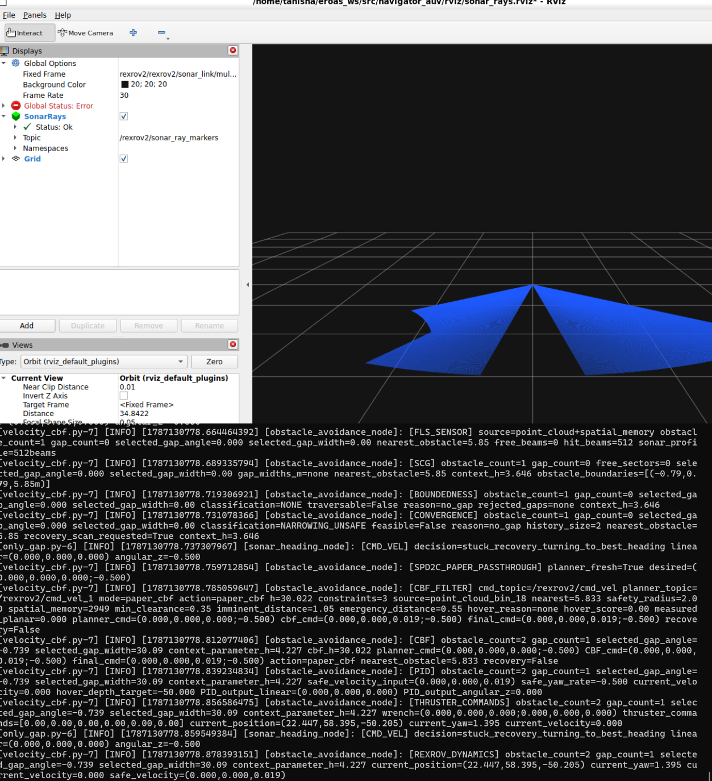

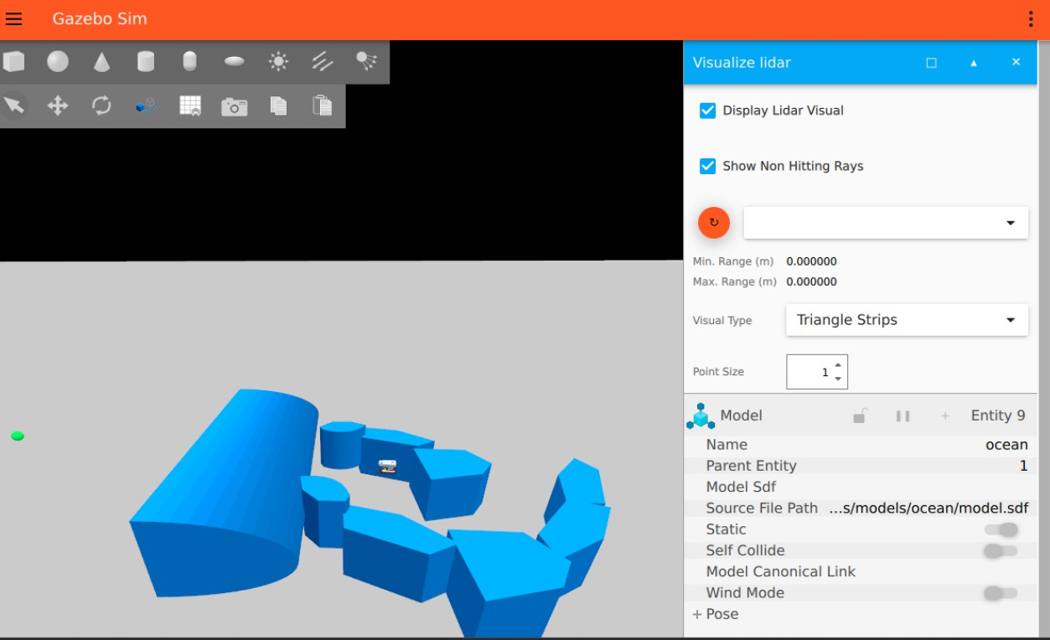

Key Issues and Challenges

A consolidated log of the issues surfaced during the reporting period, by area.

Area | Issue | Week
Tooling | LLM-agent-driven automated conversion (Ollama + Qwen 3.5) mixed up and corrupted files across the codebase, forcing a full manual restart of the migration. | Wk 2
Rendering | Blue sonar ray visualization did not render despite the underlying sonar plugin functioning correctly. | Wk 6
Rendering | Elongated / extended obstacles were not being detected due to a ray-casting resolution gap in the perception pipeline. | Wk 7
Control | Pivot mechanism did not behave as expected after migration, traced to a divergence in the thrust-mixing matrix. | Wk 7
Control | Vehicle motion exhibited near-maximum-amplitude oscillation; resolved via gain retuning and output rate limiting. | Wk 7
Rendering | Gazebo Harmonic’s VisualizeLidar plugin has no world-file default-on option, so sonar rays did not render; fixed with a dedicated marker-publishing bridge and RViz2 config. | Wk 9
Control | Vertical escape had no real depth bound and one run nearly surfaced (−50 → −14.7); fixed by ending the escape on a real-corridor signal instead of a depth/duration check. | Wk 9

Control | The vehicle repeatedly re-entered the same dead ends in World A (9 attempts, zero progress in one run); resolved with closing-corridor detection plus a dead-end heading memory shared between stuck-recovery and gap_follow. | Wk 9
Control | CBF (Control Barrier Function) constraints were incomplete after the initial port and required rework as part of the SPD2C+CBF stack integration. | Wk 8
Migration | Several conversion passes — path planning and obstacle avoidance in particular — were only partially complete and had to be revisited later in the timeline. | Wk 8

Results and Outcome

By July 7, 2026, the EROAS stack was fully migrated from ROS 1 to ROS 2 Jazzy with Gazebo Harmonic, running end to end rather than just compiling. World A’s sonar rendering and contour-based navigation worked, and the full SPD2C + CBF control stack — with waypoint hovering — was ported and integrated. Almost none of this went smoothly on the first attempt; nearly every fix came from going back to an upstream repository, a sensor plugin’s source, or a research paper rather than guessing.
A Jul 8 diagnostic then found that velocity_cbf.py wasn’t actually consuming the sonar-derived obstacle data only_gap.py was publishing, so the CBF constraints were running blind to real obstacles. The Week 9 work fixed that integration’s downstream effects sonar ray visualization, stuck-recovery for fully-boxed pinches, vertical-escape depth safety, and closing-corridor / dead-end detection each verified against headless run logs rather than code review alone. As of that most recent work, World A still does not complete reliably end-to-end: a winding multi-
pocket area (y≈60–68) continues to trap the vehicle in some runs, and the dead-end heading blacklist has no expiry or positional scoping yet. Both are open, documented issues rather than resolved ones.

Future Enhancements

- Give known_bad_headings a time or positional expiry, so a heading blacklisted near one location stops being excluded once the vehicle is far enough away that it no longer applies — documented as the direct cause of the 60+m divergence seen in the most recent verification run.
- Get World A’s winding multi-pocket area (y≈60–68) to clear reliably every individual recovery mechanism (stuck-recovery, closing-corridor detection, dead-end memory) is confirmed working in isolation, but the combination still doesn’t clear this specific area consistently.
- Extend automated regression testing across all test worlds so future changes to the control stack or sonar pipeline surface regressions immediately instead of requiring another manual headless-log verification pass.
- Investigate integrating a traversability-map-based local planner alongside the existing CBF-based avoidance, building on the RRT* / LAUV research done in Week 1.
- Document the Gazebo Harmonic plugin and marker-based visualization patterns
discovered during this migration, so future ROS 1 → ROS 2 ports of related packages don’t have to rediscover them from scratch.

Conclusion

Over the course of this engagement, the EROAS underwater navigation stack was fully migrated from ROS 1 / Gazebo Classic to ROS 2 Jazzy with Gazebo Harmonic, recovering from a failed automated-conversion attempt along the way and working through a series of rendering, sonar, and control issues that only became visible once the simulation was actually run end to end.
Nearly every non-trivial fix came from returning to an upstream repository, a sensor plugin’s source, the underlying research literature, or a headless run log rather than guessing an approach that proved slower up front but considerably more reliable. By July 7, 2026, the core port was complete and running end to end, with a working sonar pipeline and a fully integrated SPD2C + CBF control stack. The most recent work : five commits on Aug 17 fixing sonar ray visualization, stuck-recovery, and dead-end navigation pushed World A’s reliability considerably further, though it is not yet fully solved: a specific multi-pocket area still traps the vehicle in some runs, and one known root cause (an un-expiring heading blacklist) is documented but not yet fixed. That gives the next phase of work a precise, evidence-backed starting point rather than an open-ended one.

References

- AIRLabIISc/EROAS — source repository for the navigation stack migrated in this report.
- gazebosim/gz-sim — Gazebo Harmonic simulation engine and plugin architecture reference.
- gazebosim/ros_gz — ROS 2 / Gazebo Harmonic bridge reference.
- Field-Robotics-Lab/dave — DAVE underwater vehicle simulator, used as a working ROS 2 / Harmonic reference.
- uuvsimulator/nps_uw_multibeam_sonar — upstream ROS 1 / Gazebo Classic multibeam sonar simulation package.

